

**Department of mechanical engineering**

**Subject: Fundamental of programming**

**Submitted by: Zahoor Azam**

**Registration No. 453972**

**Semester :1st**

**Date: 11 oct 2023**

**Code 1:**

#include <iostream>

using namespace std;

int main(){

int n,f=1;

cout<<"Enter a number for factorial calculation: ";

cin>>n;

for(int i = n;i>=1;i--)

{

f=f*i;

}

cout<<"factorial of "<<n<<" is : "<<f;

return 0;

}

**Output:**

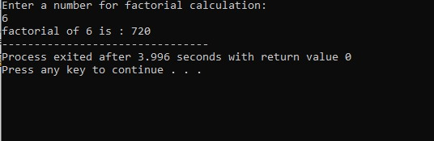

**Code 2:**

#include <iostream>

#include <cmath>

using namespace std;

int main (){

int x1,x2 ,y1,y2;

cout<<"Please enter values for x1 , x2, y1 and y2 respectively: "<<endl;

cin>>x1>>x2>>y1>>y2;

int d = pow ((x2-x1),2)+pow((y2-y1),2);

cout<<”THE DISTANCE BETWEEN POINTS IS <<endl;

cout<<d;

return 0;

}

**Output:**

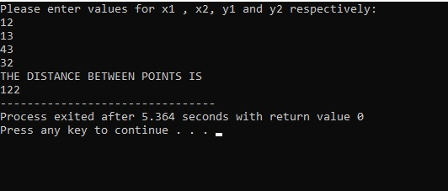

**Code 3:**

#include <iostream>

using namespace std;

int main (){

int c, m, km;

cout<<"Enter value in cm: "<<endl;

cin>>c;

m = c/100;

km = m/1000;

cout<<"The value in meter is: "<<m<<" The value in kilo meter is: "<<km<<endl;

return 0;

}

**Output:**

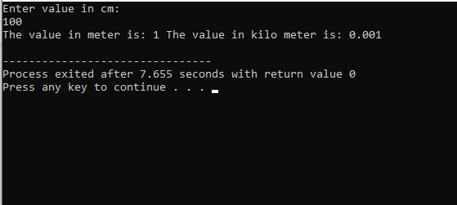

**Code 4:**

#include <iostream>

#include <cmath>

using namespace std;

int main (){

int a, b;

cout<<"Please enter value for a and b: "<<endl;

cin>>a>>b;

int p = pow(a,2)+2*a*b+pow(b,2);

cout<<"The polynomial formula is: "<<p;

return 0;

}

**Output:**

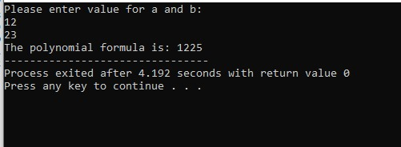

**Code 5:**

#include<iostream>

using namespace std;

int main(){

float A;

cout<<"ENTER YOUR MARKS ASSIGNED IN EXAMINATION."<<endl;

cin>>A;

if(90<=A && 100>=A){

cout<<"GRADE A";

}

if(75<=A && 90>=A){

cout<<"GRADE B";

}

if(60<=A && 75>=A){

cout<<"GRADE C";

}

if(45<=A && 60>=A){

cout<<"GRADE D";

}

if(0<=A && 45>=A){

cout<<"GRADE E";

}

**Out put:**

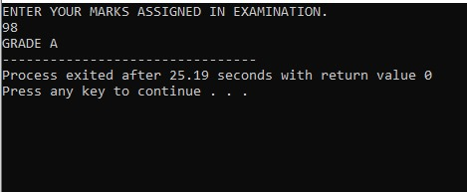

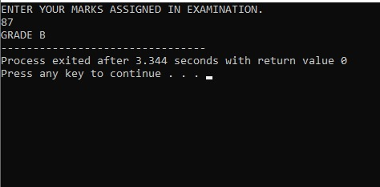

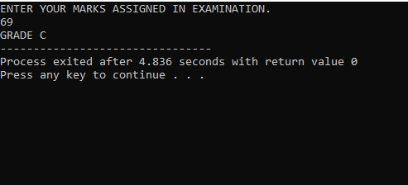

**Code 6:**

#include<iostream>

using namespace std;

int main(){

float A,B;

cout<<"ENTER YOUR GPA ."<<endl;

cin>>A;

cout<<"ATTENDANCE"<<endl;

cin>>B;

if(A>=3.5 && B>=80 ){

cout<<"YOU ARE ELIGIBLE FOR THIS SCHOLARSHIP.";

} else {

cout<<"YOU ARE NOT ELIGIBLE FOR THIS SCHOLARSHIP";

}

}

**Output:**

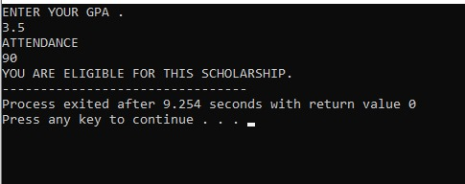

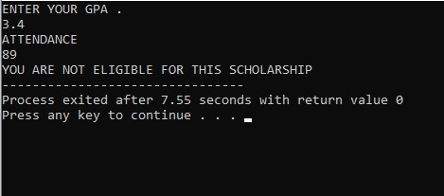

**Code 7:**

#include<iostream>

using namespace std;

bool isvowel(char x) {

return (x == 'a' || x == 'e' || x == 'i' || x == 'o' || x == 'u');

}

int main(){

char x;

cout<<"ENTER ANY ALPHABET."<<endl;

cin>>x;

if (isvowel(x)){

cout<<"IT IS VOWEL.";

} else {

cout<<"IT IS CONSONANT.";

}

return 0;

}

**Output:**

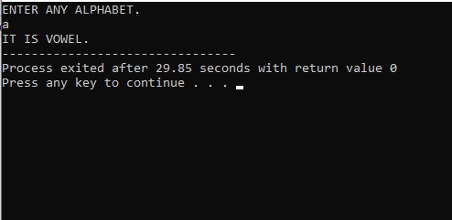

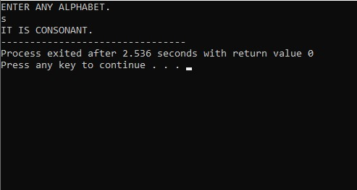

**Code 8:**

#include<iostream>

using namespace std;

bool isLeapyear(int year){

return (year % 4 == 0 && year % 100 != 0) || year % 400 == 0;

}

int main(){

int year ;

cout<<"ENTER ANY YEAR YOU WANT TO CHECK IF IT IS LEAP YEAR OR NOT :"<<endl;

cin>>year ;

if(isLeapyear(year)){

cout<<"IT IS LEAP YEAR.";

} else {

cout<<"IT IS NOT LEAP YEAR";

}

return 0;

}

**Output:**

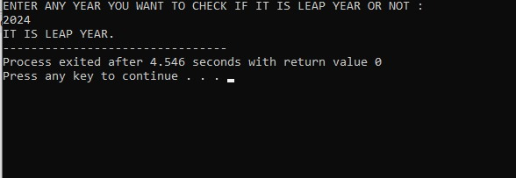

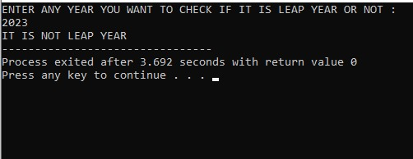

**Code 9:**

#include<iostream>

using namespace std;

int main(){

int a;

cout<<"ENTER ANY NUMBER."<<endl;

cin>>a;

if(a%2==0 && a%5==0){

cout<<"IT IS BOTH,EVEN AND DIVISIBLE BY 5.";

}

if(a%2==0 && a%5!=0){

cout<<"IT IS EVEN BUT NOT DIVISIBLE BY 5.";

}

if(a%2!=0 && a%5==0){

cout<<"IT IS DIVISIBLE BY 5 BUT NOT EVEN.";

} if(a%2!=0 && a%5!=0){

cout<<"IT IS ODD NUMBER.";

}

}

**Output:**

